eIDEAS

User Manual

Version 1.0

October 23rd, 2018

University of Regina

Health-Esteem

Quinn Bast

Wilson Nye

Shawn Clake

Tristan Heisler

Jennifer Herasymuik
Revision History

Version Number | Change Summary | Date | Updated By
1.0 | Initial draft of the | 10/23/18 | Quinn Bast
 | user manual

Table of Contents

About this guide | 4
Viewing the Home Page | 4
The navigation bar | 5
User Accounts | 5
Registering a new account | 6
Logging in with an existing account | 8
Recovering a lost password | 8
Logging out | 8
The dashboard | 8
Viewing Ideas | 8
Filtering the dashboard | 8
Ideas | 8
Creating an idea | 8
Updating an idea | 8
Idea status | 8
Common Errors | 8
I can’t view my ideas | 8
I can’t login | 8
Page not found | 8
My idea got deleted | 8
Glossary | 8

1. About this guide

This guide is intended to describe how to use the eIDEAS application which has been created for eHealth by the University of Regina’s Health-Esteem team. This guide provides basic information for end-users of the application and covers the general topics of ‘Accounts’, ‘Ideas’, ‘Points’, and ‘Administration’.

2. Viewing the Home Page

When first opening the website, the homepage will appear. On the homepage, the user is provided with a featured image carousel as well as text segments outlining success stories, and what’s new. In addition to this featured content, a navigation bar is provided which allows the user to access the FAQ, Contact, Register, and Login pages.


2.1. The navigation bar

When first accessing the site, if the user is not logged in, the navigation bar will appear as in the following image:

Each button on the navigation bar is numbered and their explanation is given

below.

1 | eIDEAS | This button will take the user to the home page
2 | FAQ | This button will take the user to the FAQ page. This page provides a
 |  | list of commonly asked questions and basic instructions about how
 |  | the website works.
3 | Contact | This button will take the user to the contact page. The contact page
 |  | provides the user access to eHealth emails, phone numbers, and
 |  | address for quick access.
4 | Register | This button will take the user to the user registration page. This page
 |  | will allow a user to create an account.
5 | Login | This button will take the user ot the user login page. This page
 |  | allows users with existing accounts to login to the website.

3. User Accounts

In order to access the website, a user must have registered for an account. Users are required to create an account in order to save the user’s ideas, drafts, comments, ratings, and more.

3.1. Registering a new account

In order to register a new account, ensure that a user is not currently logged in. When a user is logged into the website the ‘Register’ tab does not appear within the navigation bar. In order to get to the account registration page, click the ‘Register’ button from the navigation menu as seen below.
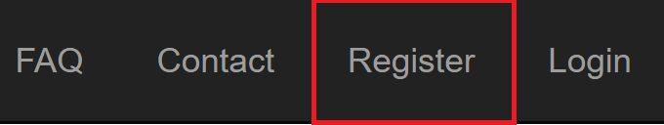

After clicking the Register button, the user is provided with the registration page as seen below.
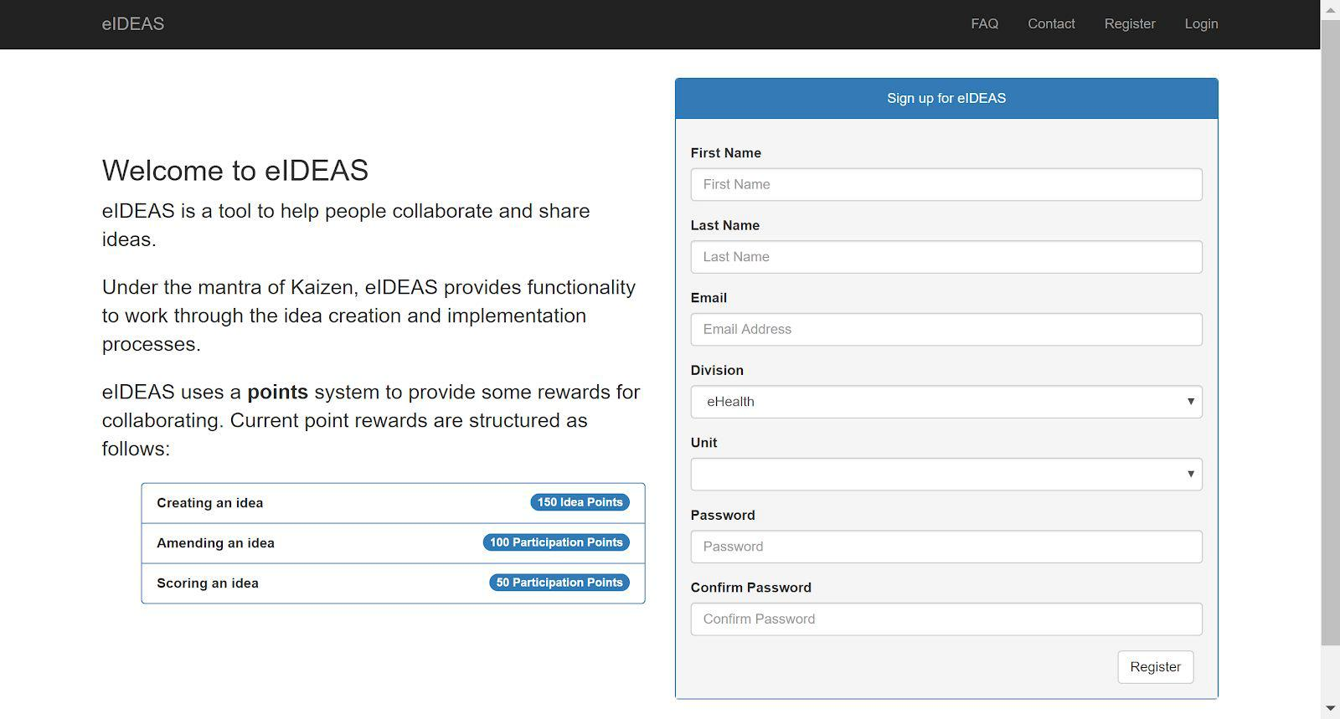

In order to create an account, the user needs to provide the following information:

First Name The user’s first name.
Last Name | The user’s last name.
Email | The user’s email. This will allow the
 | user to recover their password and
 | receive optional email notifications.
Division | The eHealth division that the user
 | works within.
Unit | The unit within the division where the
 | user works.
Password | The user’s password.
Confirm Password | Retype the user’s password.

Some of the above fields have a required format. If this format is not met,

a message will appear underneath the field showing the user that there is a

problem with the information entered.

3.2. Logging in with an existing account
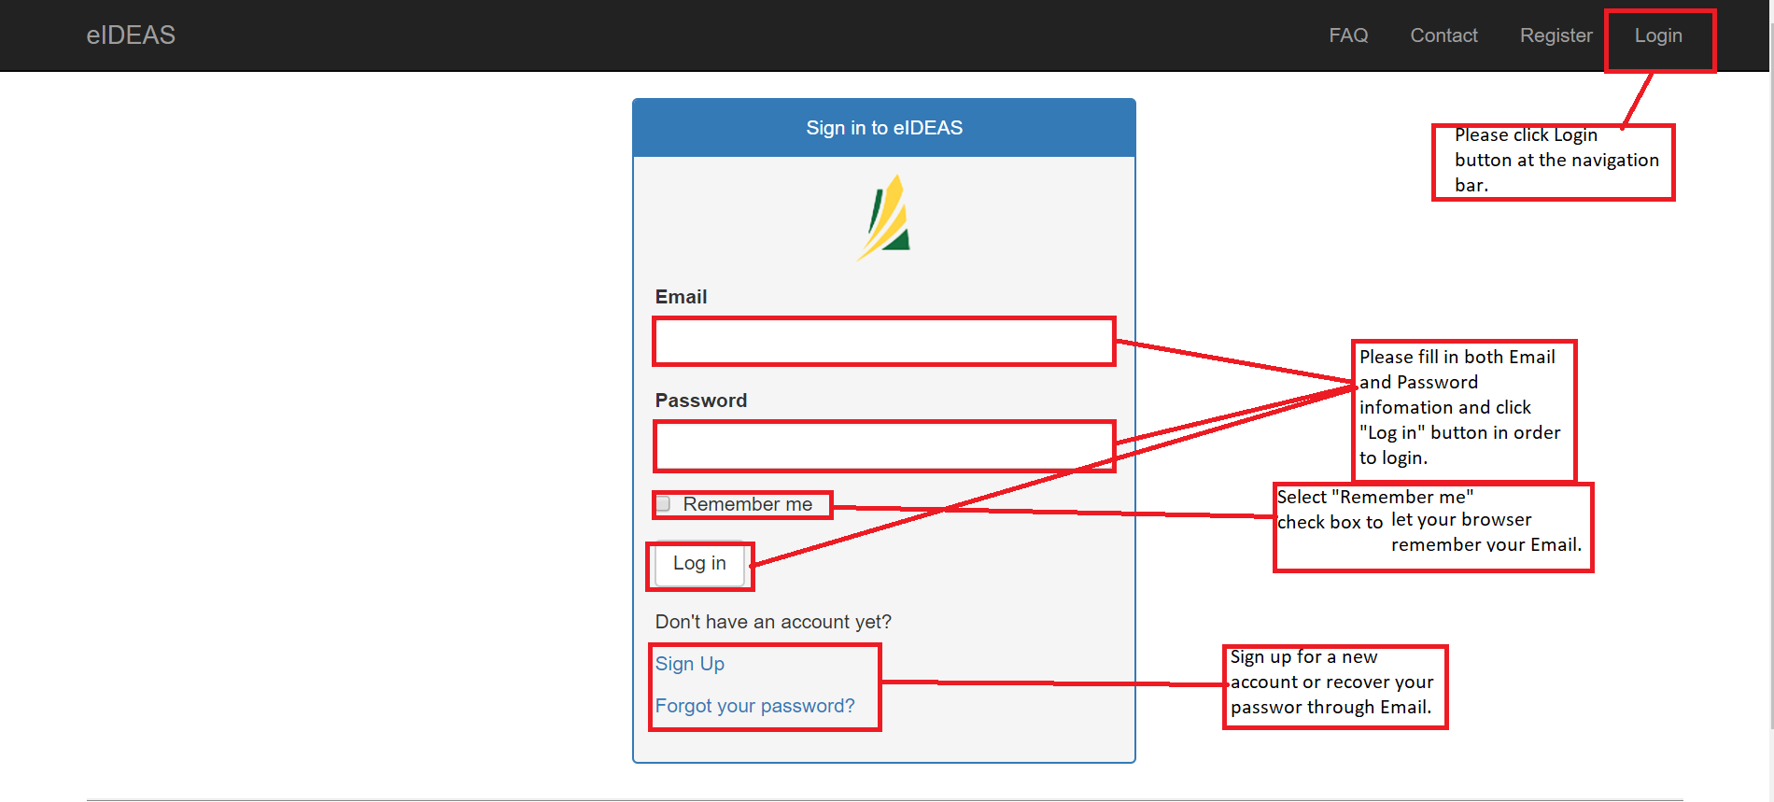

3.3. Recovering a lost password
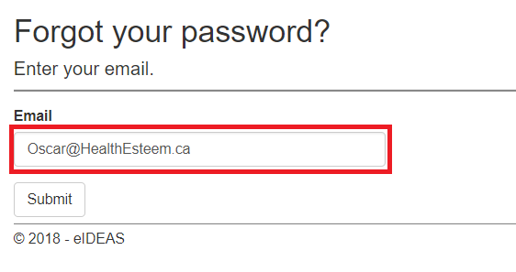

If you forget your password, please enter your email address in the text input bar and hit submit. Then, you will receive a confirmation email to verify your identification.
3.4. Logging out

4. The dashboard

4.1. Viewing Ideas
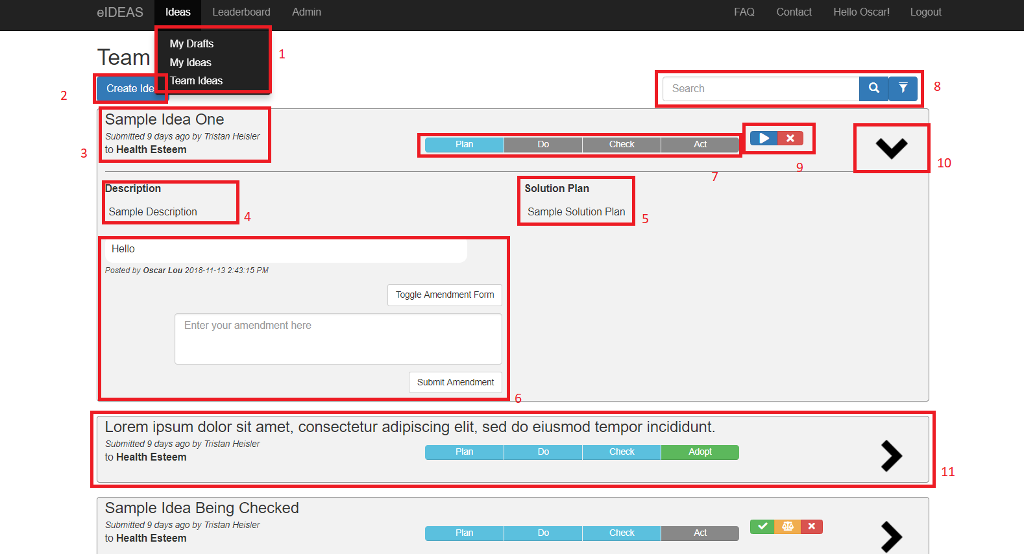

1. A menu allows user to select viewing options.
2. Create new idea.
3. Displays Idea title, author name and Department name.
4. Idea description.
5. Solution plan.
6. Amendment panel, View and Edit amendment at real time.
7. Current process status.
8. Ideas Filter. More detail at 4.2.
9. Advance ideas into next stage or finalize ideas.
10. Click this button to expand detailed idea information.
11. A typical collapse view of the idea.

4.2. Filtering the dashboard
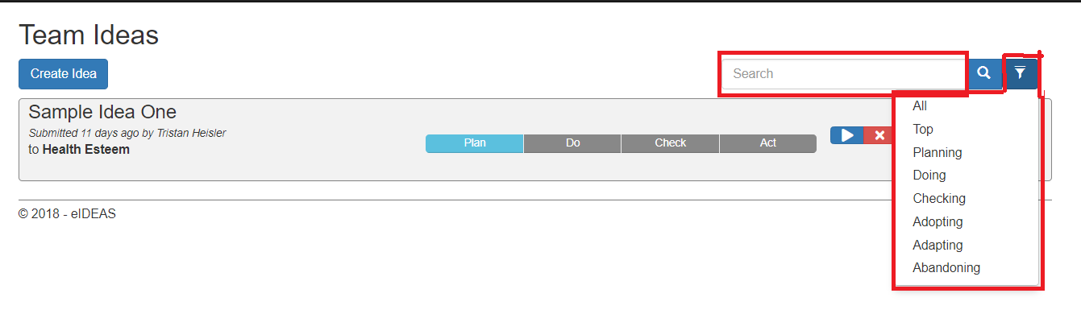
1. Search bar
2. This button allows users to select a status and it will displays all Ideas are current in that stage.

5. Ideas

5.1. Creating an idea
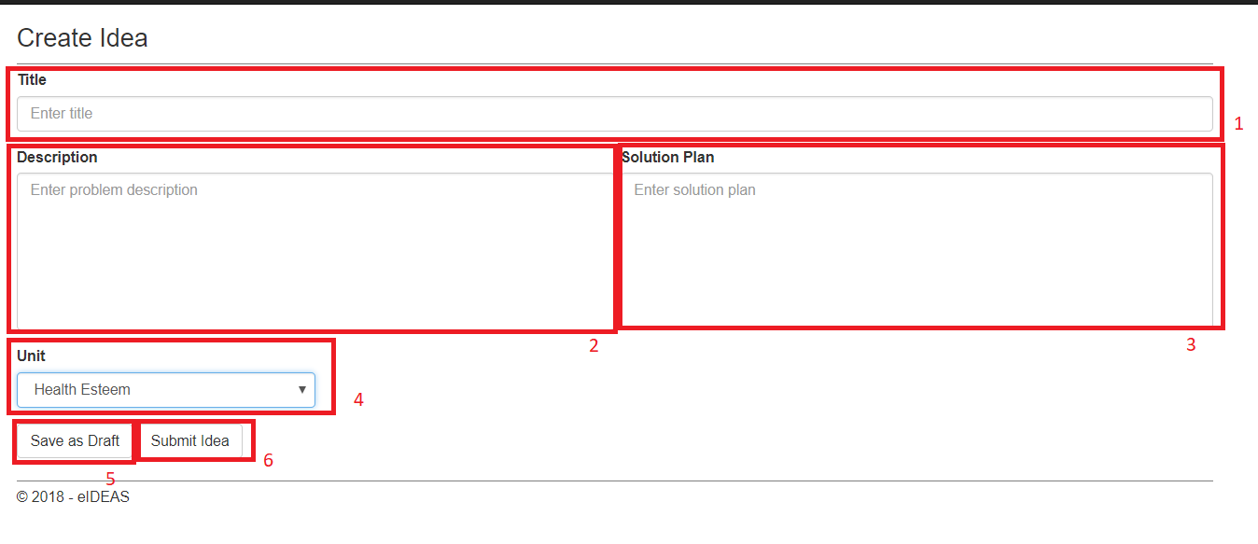
1. Enter idea title
2. Enter description.
3. Enter Solution plan.
4. Select an unit you belong to.
5. Save your your idea as draft.
6. submit your idea.

5.2. Updating an idea

5.3. Idea status

6. Common Errors

6.1. | I can’t view my ideas
6.2. | I can’t login
6.3. | Page not found
6.4. | My idea got deleted

Glossary

